**CSE 3215**

**Quiz 3 (Section A2)**

**Time: 20 minutes**

**Marks: 10**

* 1. Derive the formula $\frac{Vout}{Vin}= - \frac{Rf}{Rin}$ of an inverting amplifier. (2)
  2. (3)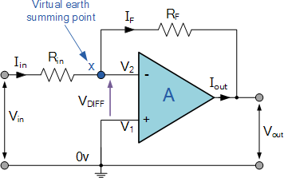

For the above figure, let RF = 200 kΩ, Rin = 10 kΩ and Vin = 2V. Calculate I, Av, and Vo.

* 1. A DAC is showing 4.2V output for the input code 101010. Calculate the LSB and Reference voltage if it operates within 2V to 12V. (2)
  2. Describe the process of Data Acquisition System. (3)

Solution:

1. (b) : I = 0.2mA Vo = -40V Av = -20

2. (a): Vref = 6.402V LSB = 12/2^6 = 0.1875